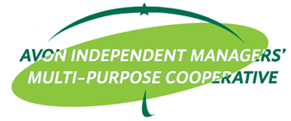
AVON INDEPENDENT MANAGERS' MULTI PURPOSE COOPERATIVE
884 Samat St., Brgy. Highway Hills, Mandaluyong City
Cell Nos. 0908-8202614/ 0917-5178903 Tel nos. 717-7093/ 535-7969

LETTER OF INTENT
May __, 2022

Ms. ___________________
Election Committee
AIM-MPC

Dear Sir/Madam:

I, ___________________________, from ______________ branch signify my intention for the
(name) (branch)

position of ___________________________ this coming ______________ election.
(position/committee) (year)

Thank you.

_________________________
Signature over printed name

